Project Design Phase-I
Problem – Solution Fit Template

Date | June 2026
Team ID
Project Name | Heart Disease Analysis
Maximum Marks | 2 Marks

Problem – Solution Fit Template:
The Problem–Solution Fit means identifying a real problem faced by patients and healthcare providers and ensuring that the proposed Heart Disease Analysis System effectively addresses that problem. It helps healthcare organizations and developers understand patient needs, improve diagnosis, and increase adoption of AI-based healthcare solutions.
Purpose:
☑ Solve complex problems by enabling early prediction and diagnosis of heart disease using patient health data and machine learning techniques.
☑ Succeed faster and increase solution adoption by providing healthcare professionals with a reliable decision-support system that integrates with existing clinical workflows.
☑ Sharpen communication and awareness strategies by educating patients about heart disease risk factors and promoting preventive healthcare through timely alerts and recommendations.
☑ Increase touch-points with healthcare providers by offering accurate risk assessment, reducing diagnostic delays, and improving trust through data-driven predictions.
☑ Understand the existing healthcare situation by analyzing patient medical records, identifying key risk factors such as age, blood pressure, cholesterol, diabetes, and heart rate, and providing insights that support early intervention, better treatment planning, and improved patient outcomes.

Template:
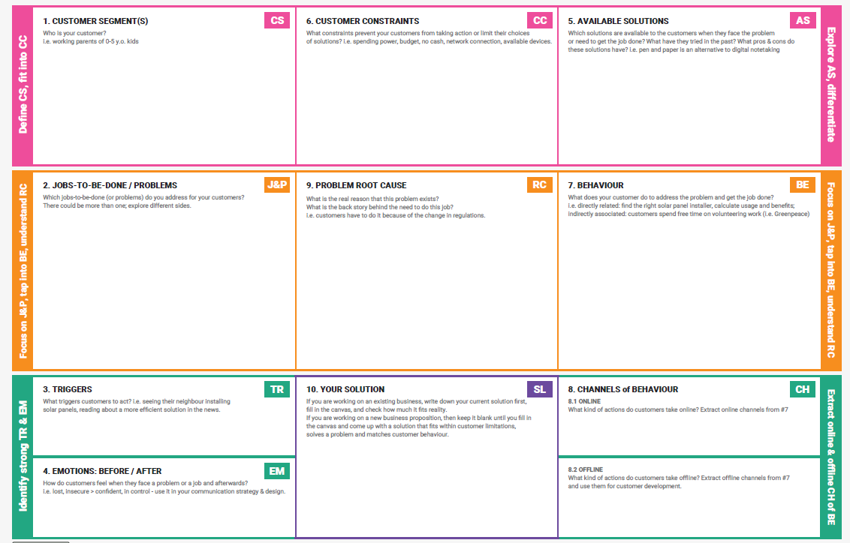
References:
- https://www.ideahackers.network/problem-solution-fit-canvas/
- https://medium.com/@epicantus/problem-solution-fit-canvas-aa3dd59cb4fe

